**Image processing & Machine Vision**

**Assignment Report**

**Assignment - I**

MPSM Pathirana

D/ENG/22/0061/EE

Department of Electrical, Electronic and Telecommunication Engineering

**Content**

1. Question 01
2. Question 02
3. Question 03
4. Question 04
5. Question 05
6. Question 06
7. Question 07
8. Question 08
9. GitHub link

**Discussion**

Intensity transformation plays a crucial role in adjusting the overall brightness, contrast, and other adjustment of the images. Also, intensity transformation is the fundamental process in image processing that can modifying the pixel values. I attached the code and results.

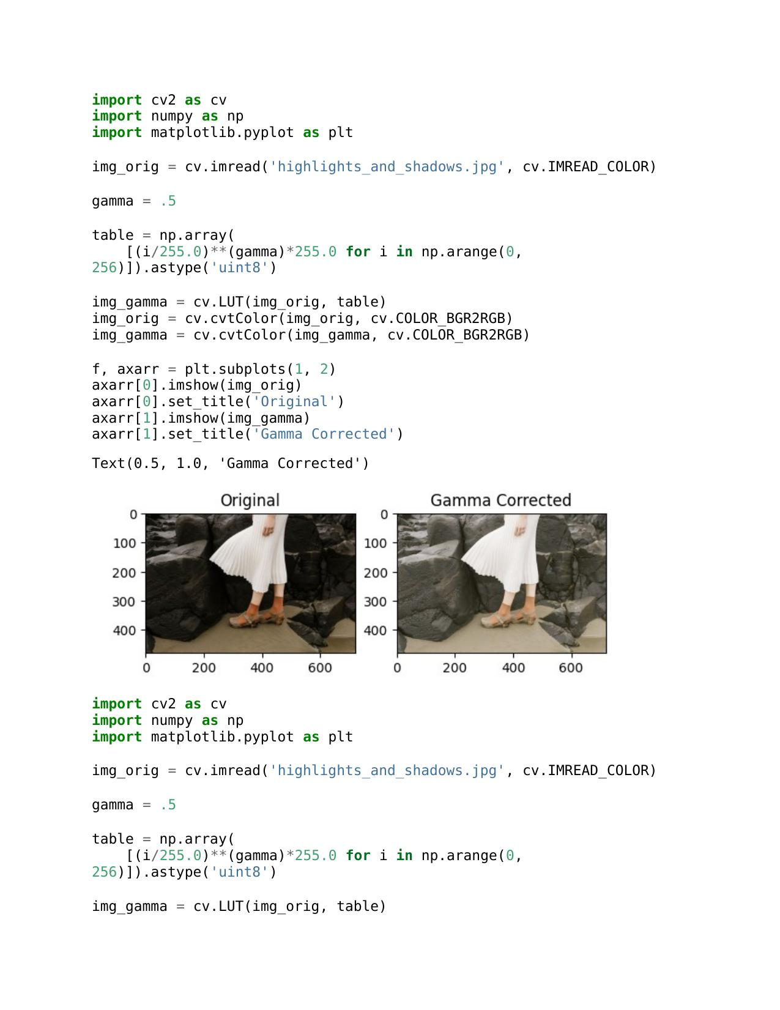**Question 02**

a.

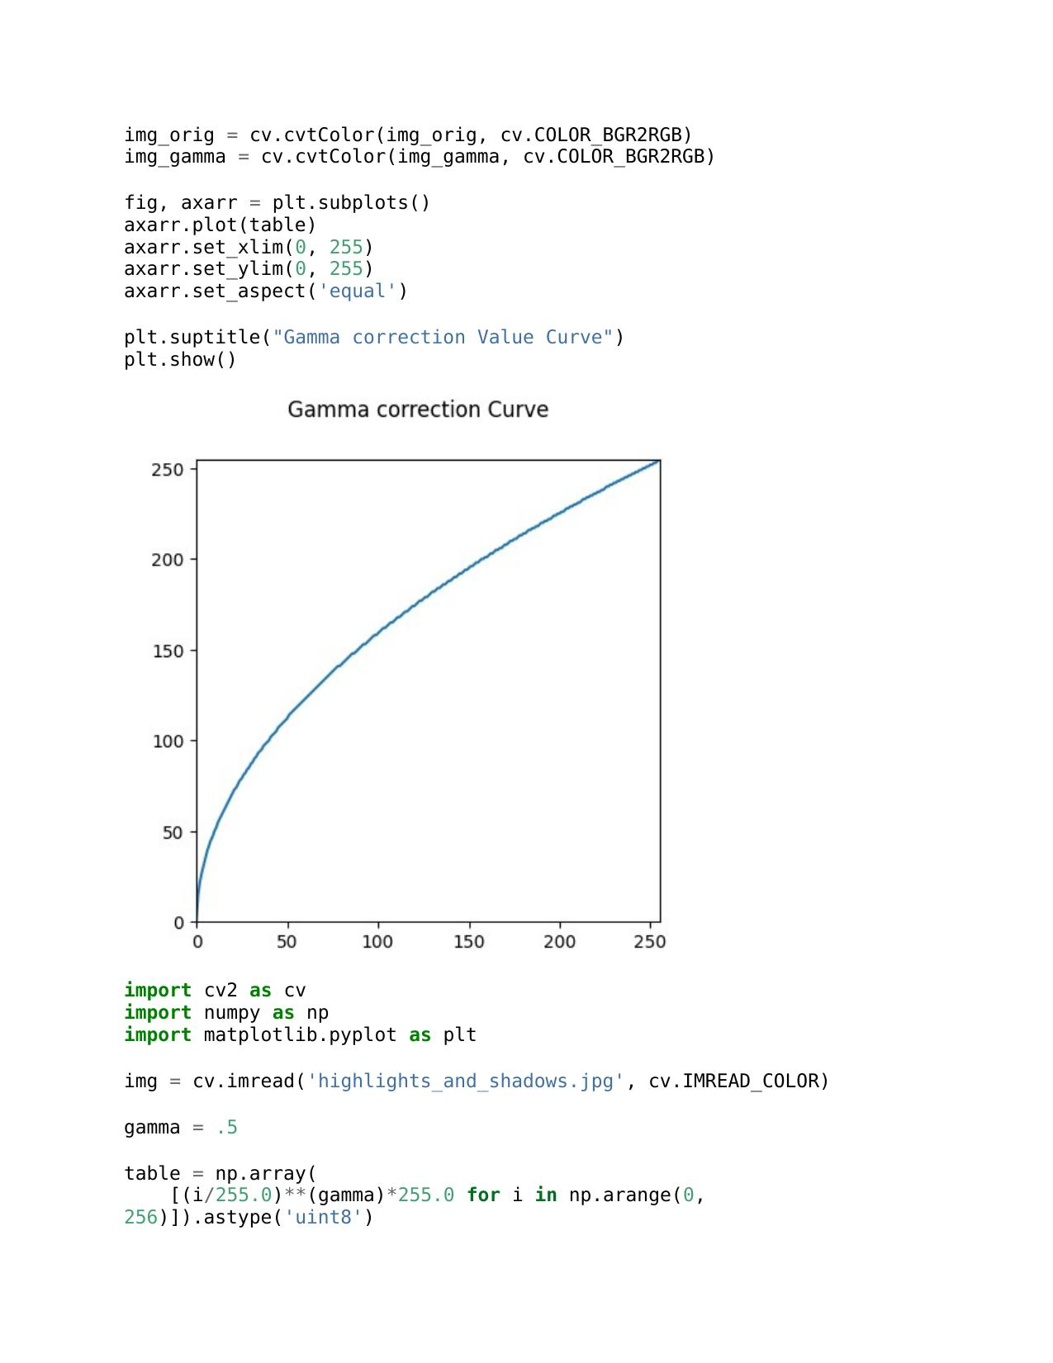

b...

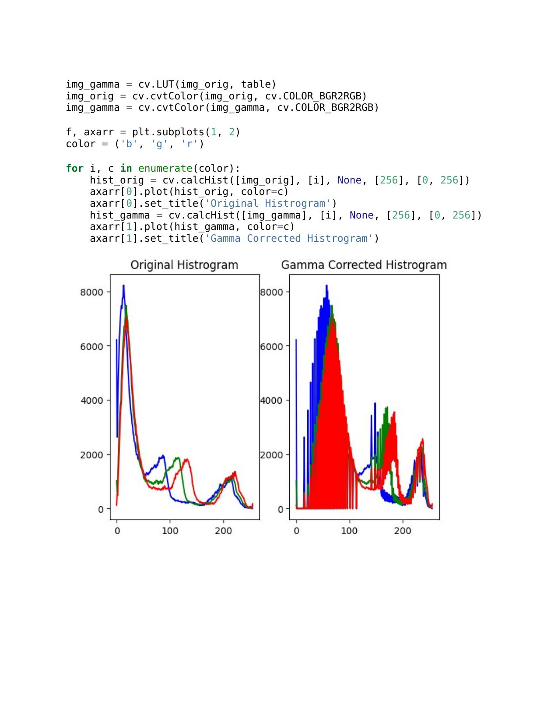

**Discussion**

Histograms show a visual representation of the distribution of pixel intensities in an image.

Original Histogram color spaces reflects the pixel intensities in the L channel. Indicate how common each intensities level is within the image. After applying gamma correction alter the relationship between the input and output pixel intensities this one affected to overall brightness and contrast.

a.

b...

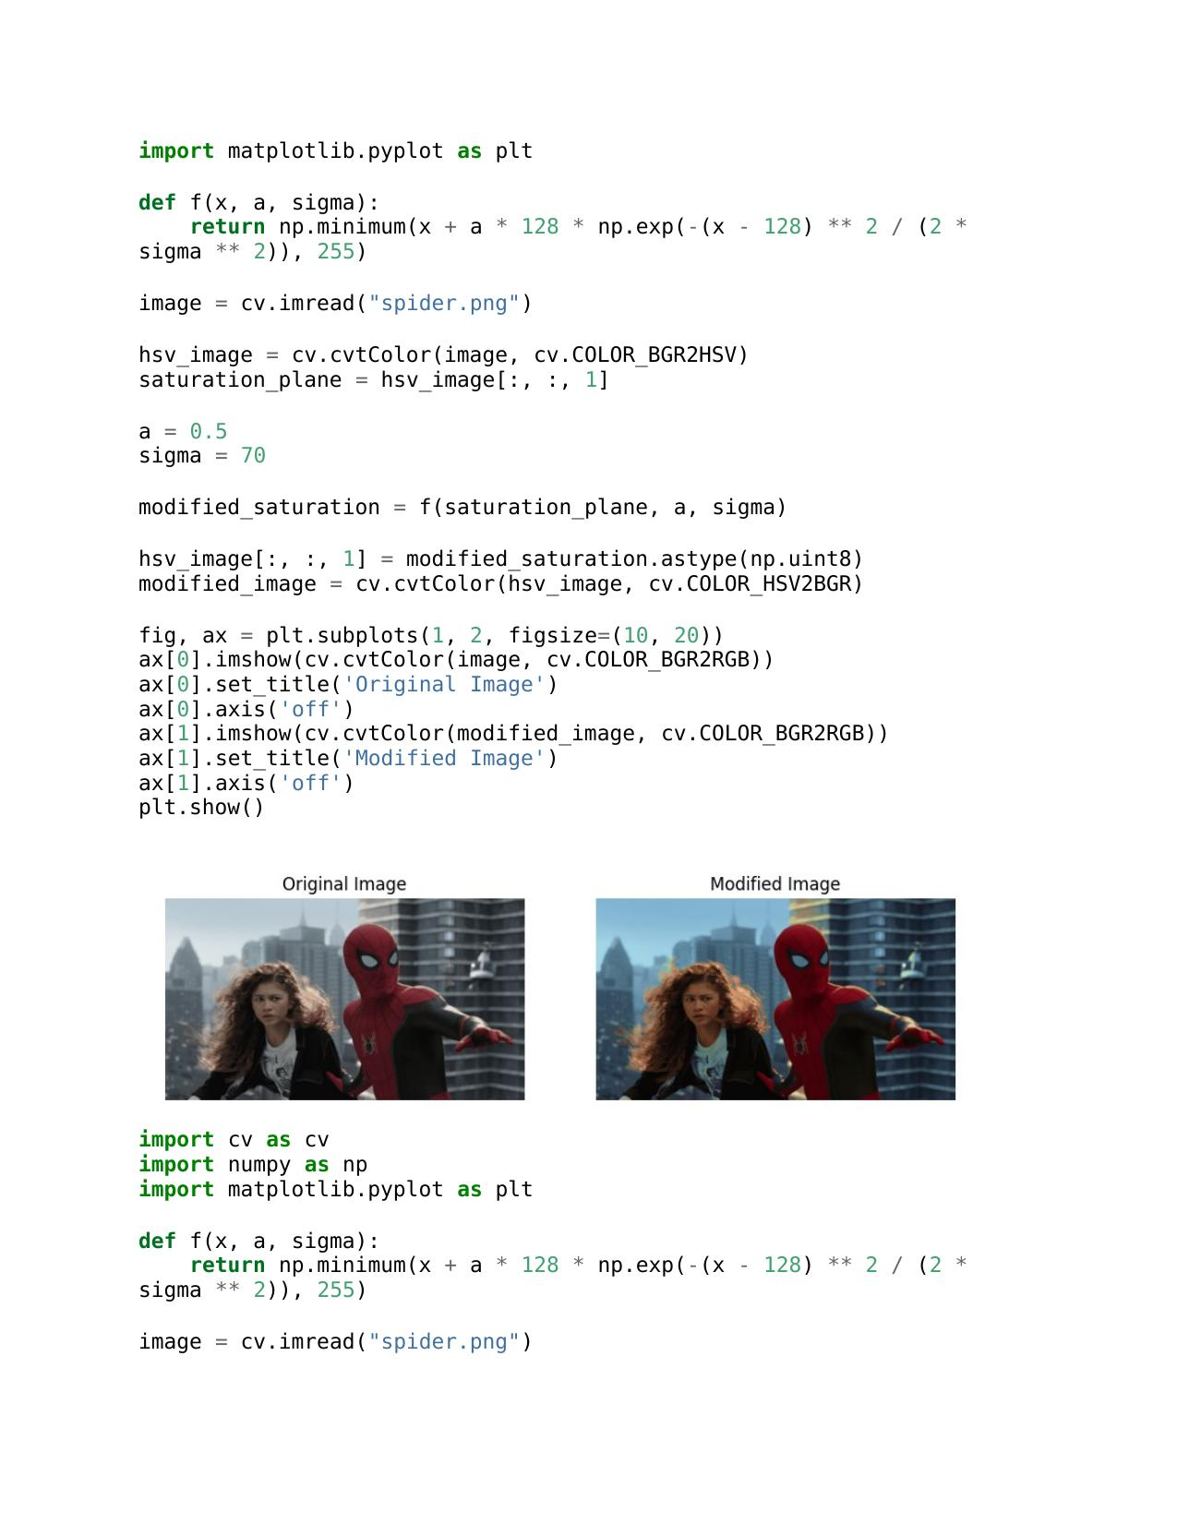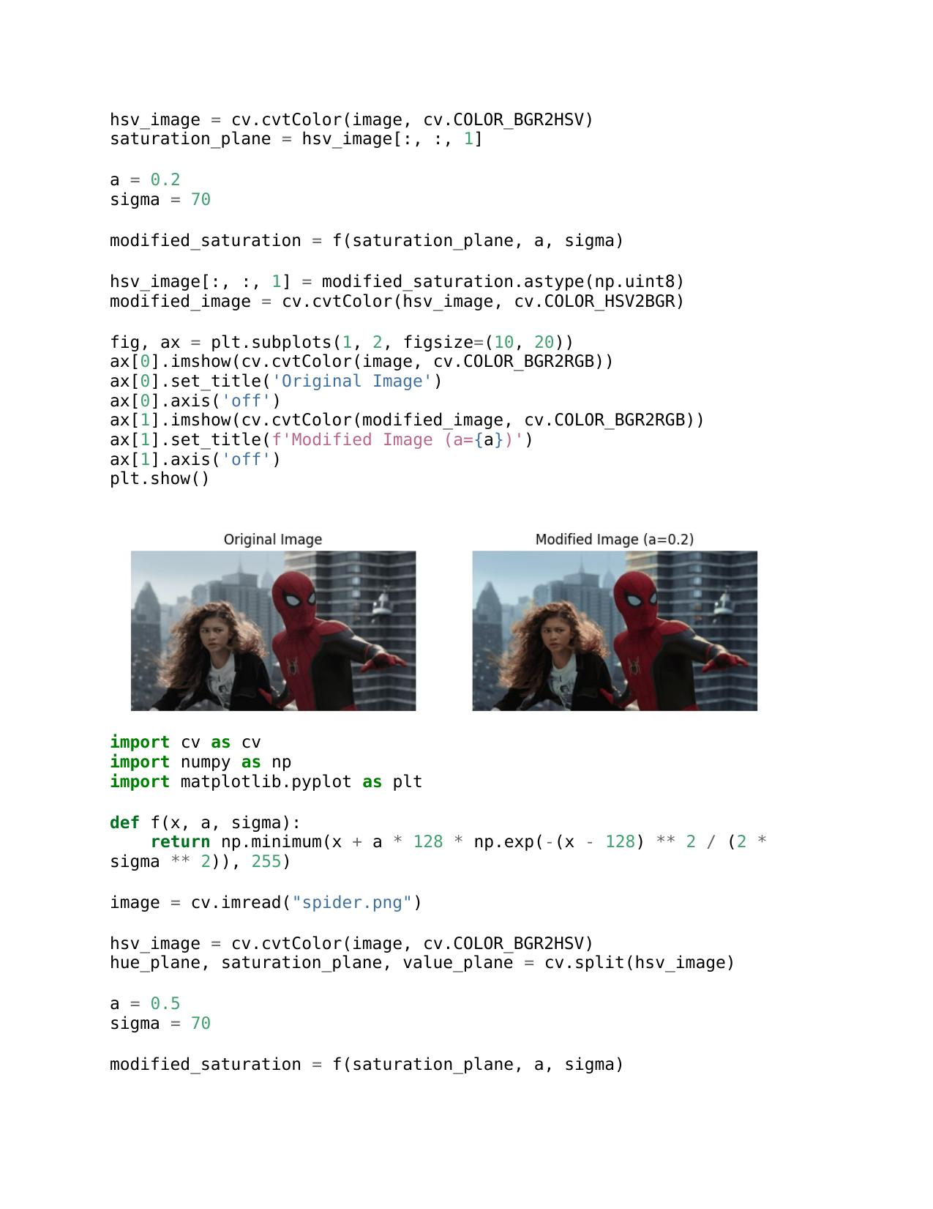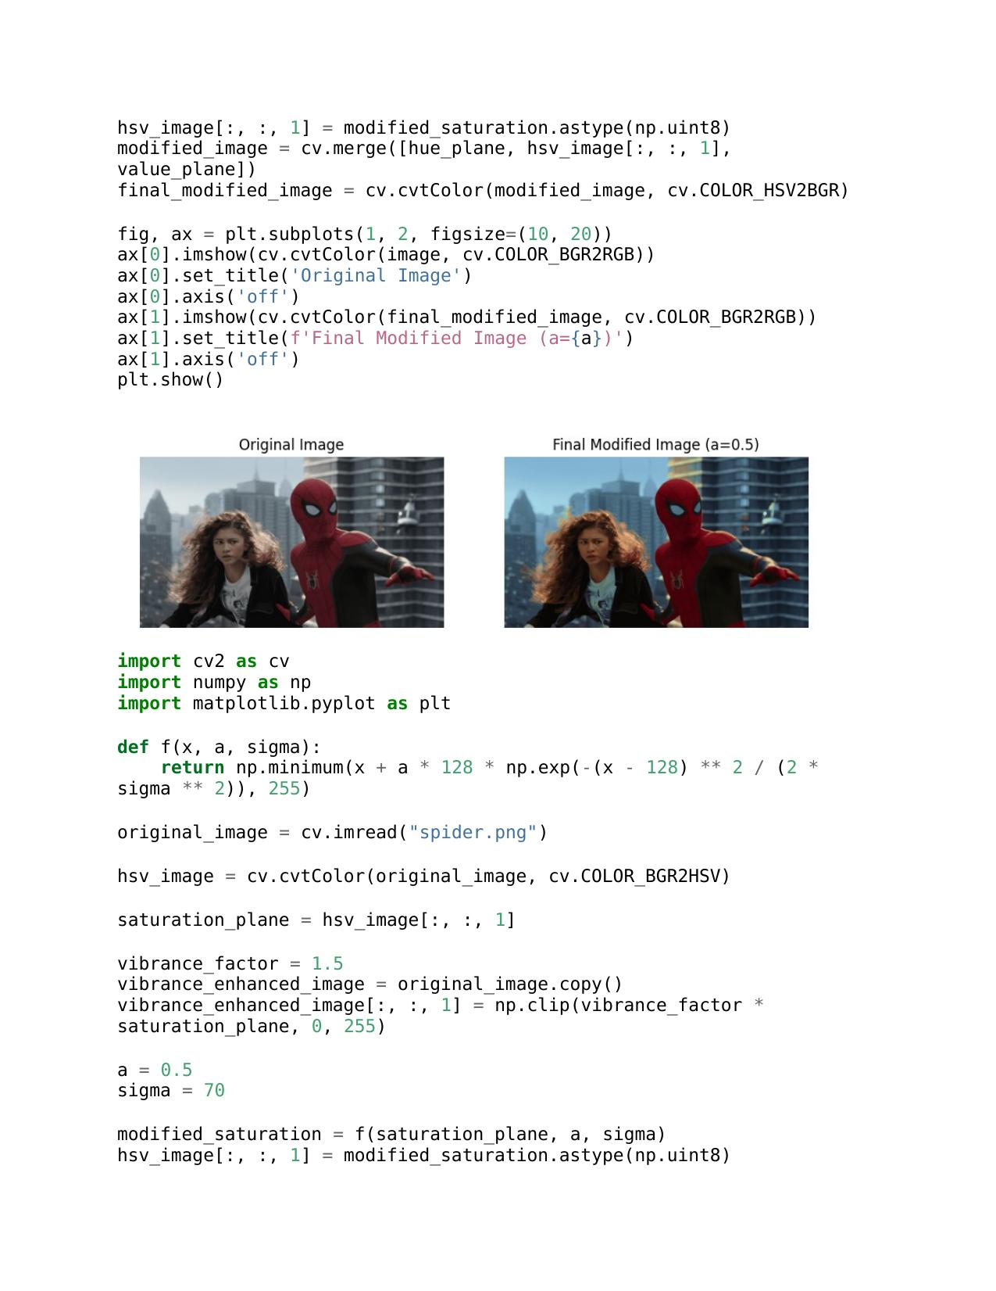

c.

d.

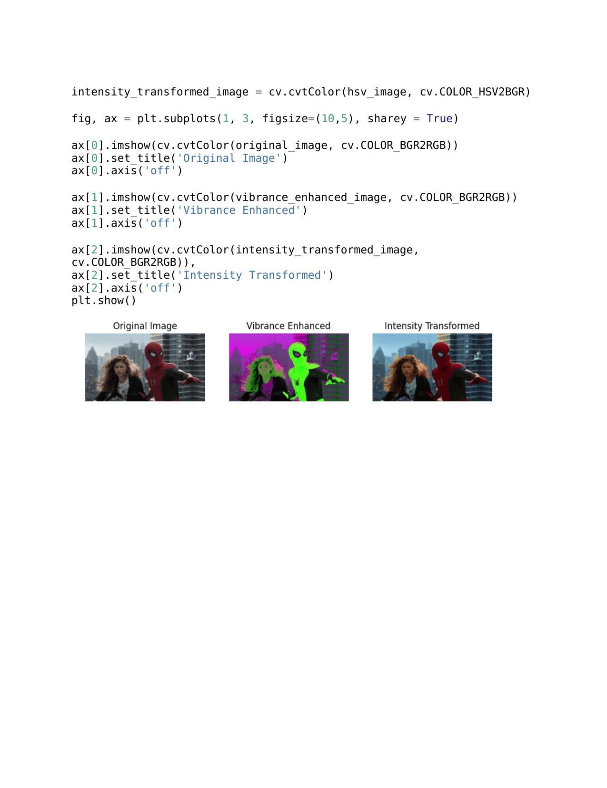

**Discussion**

Under this question we consider image enhancement process after we increase the vibrance of a image by applying intensity transformation to the saturation, HUE, HSV planes.

Considering these three planes we focus directed towards enhancing and bring out more vivid colors. The intensity transformation involves a parameter ‘a’ is adjusted to achieve a pleasing vibrance enhancement.

**Question 04**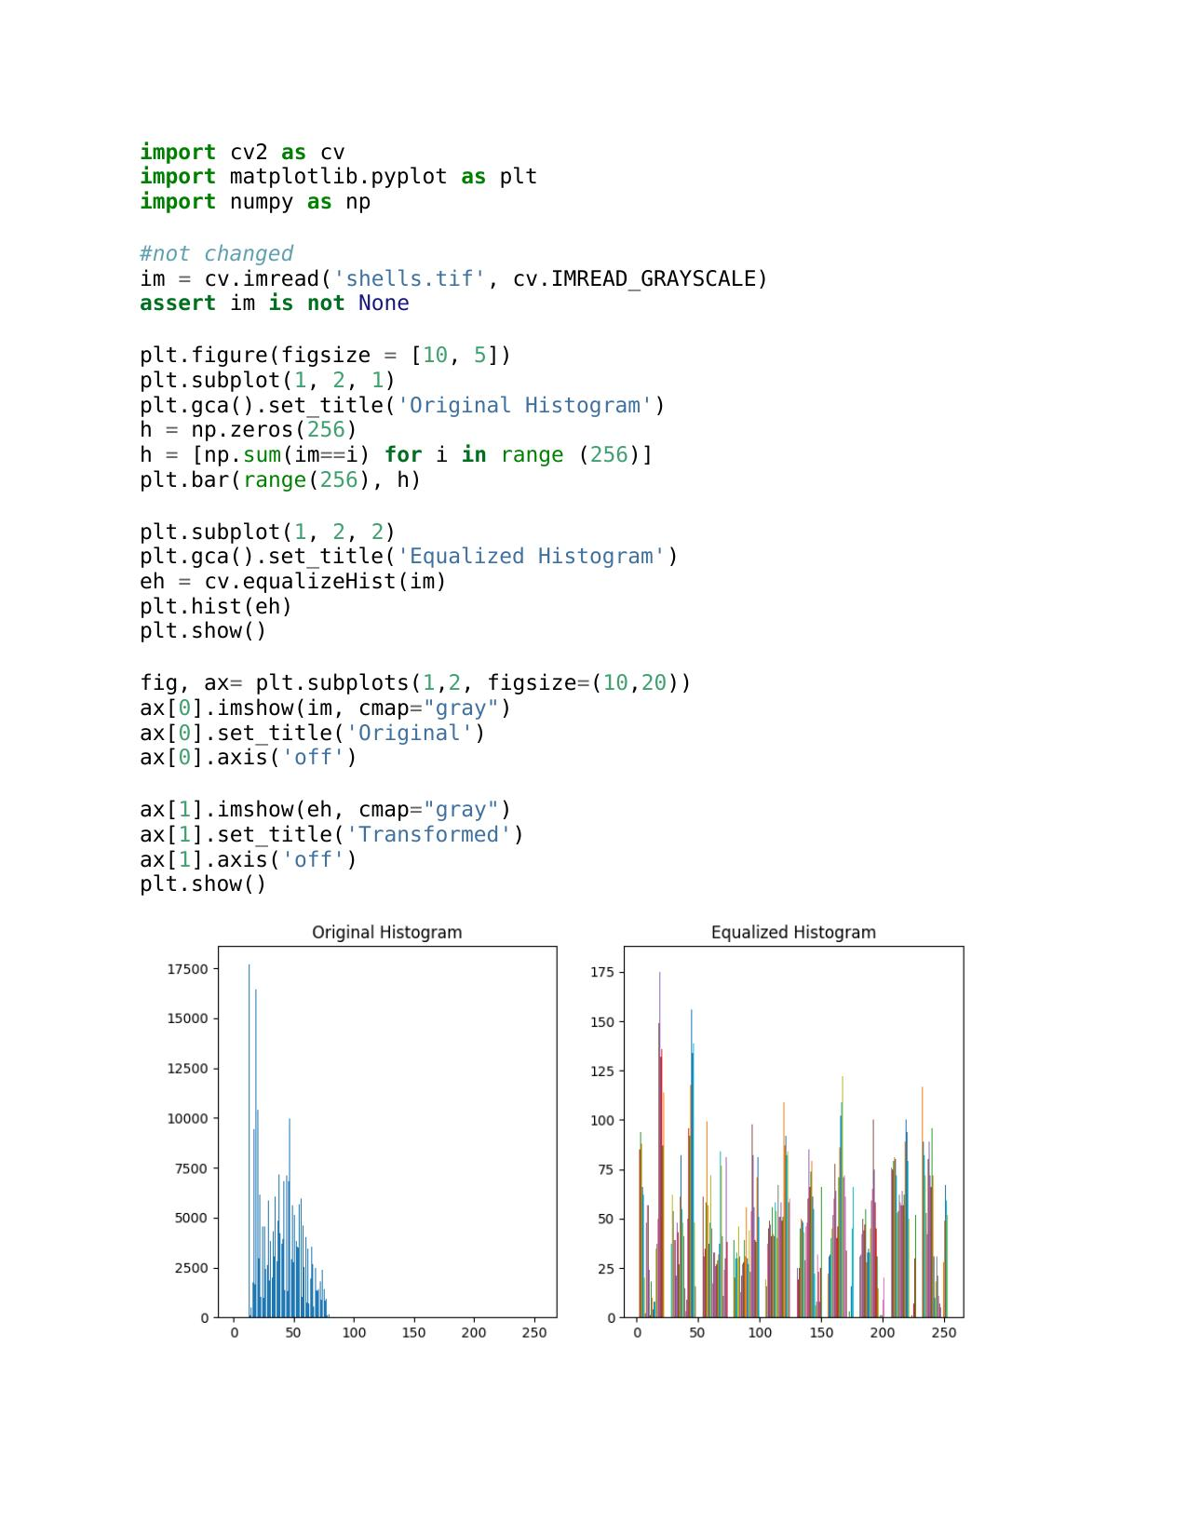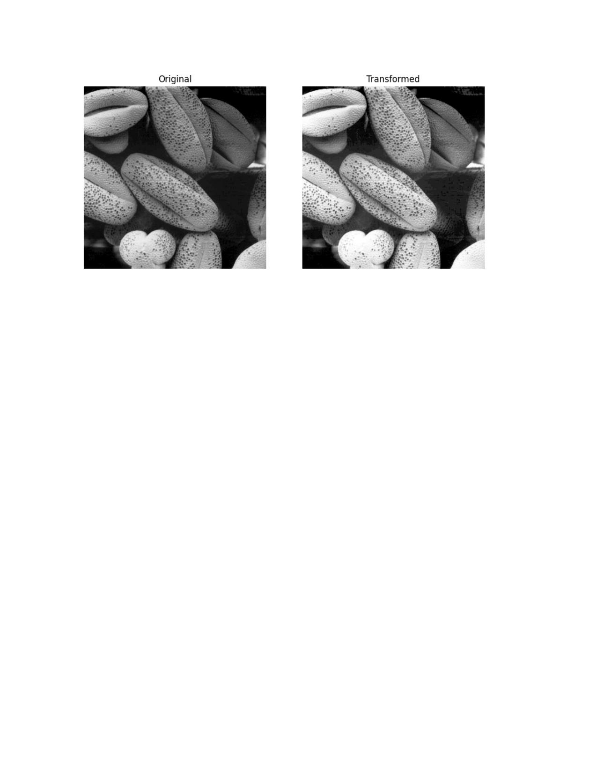

**Question 05**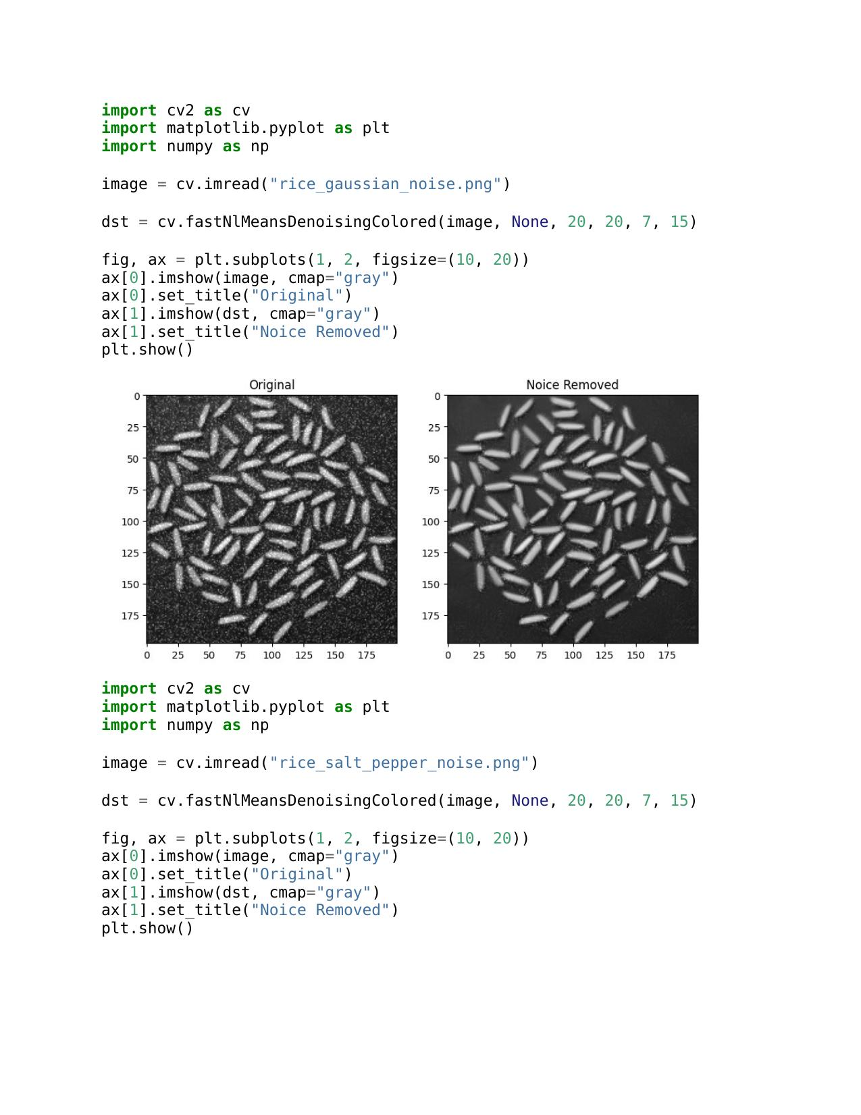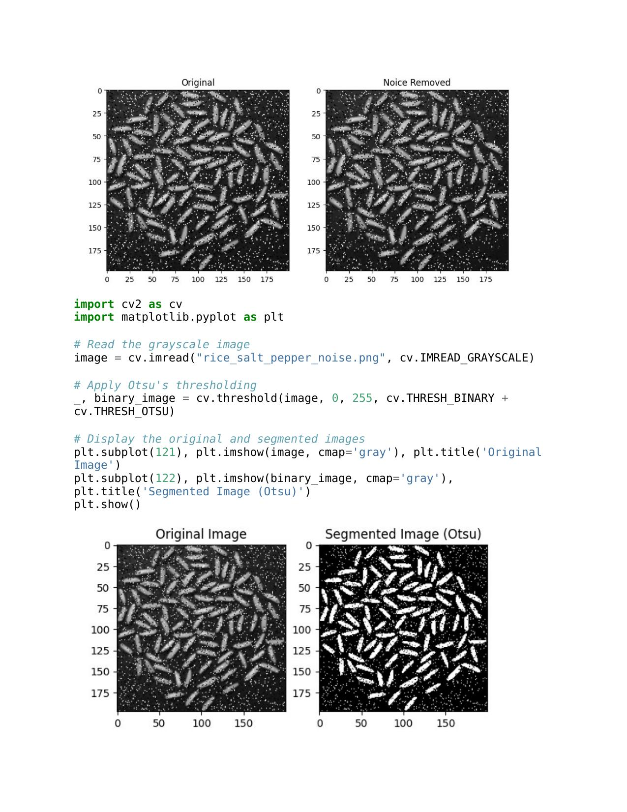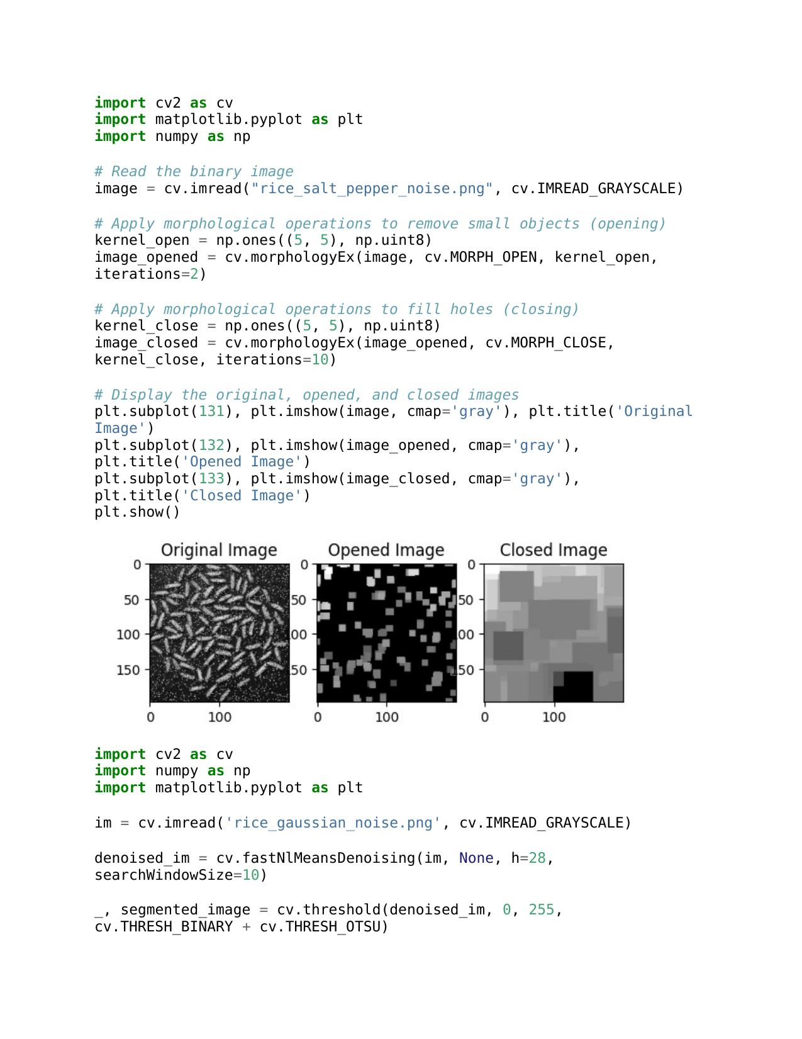

b.

a.

c.

e.

d.

**Discussion**

Otsu’s method applied to segment the images, disfurnishing rice grains from the background. Morphological operations refine the segmentation by eliminating small artifacts and filling in gaps.

**Question 06**

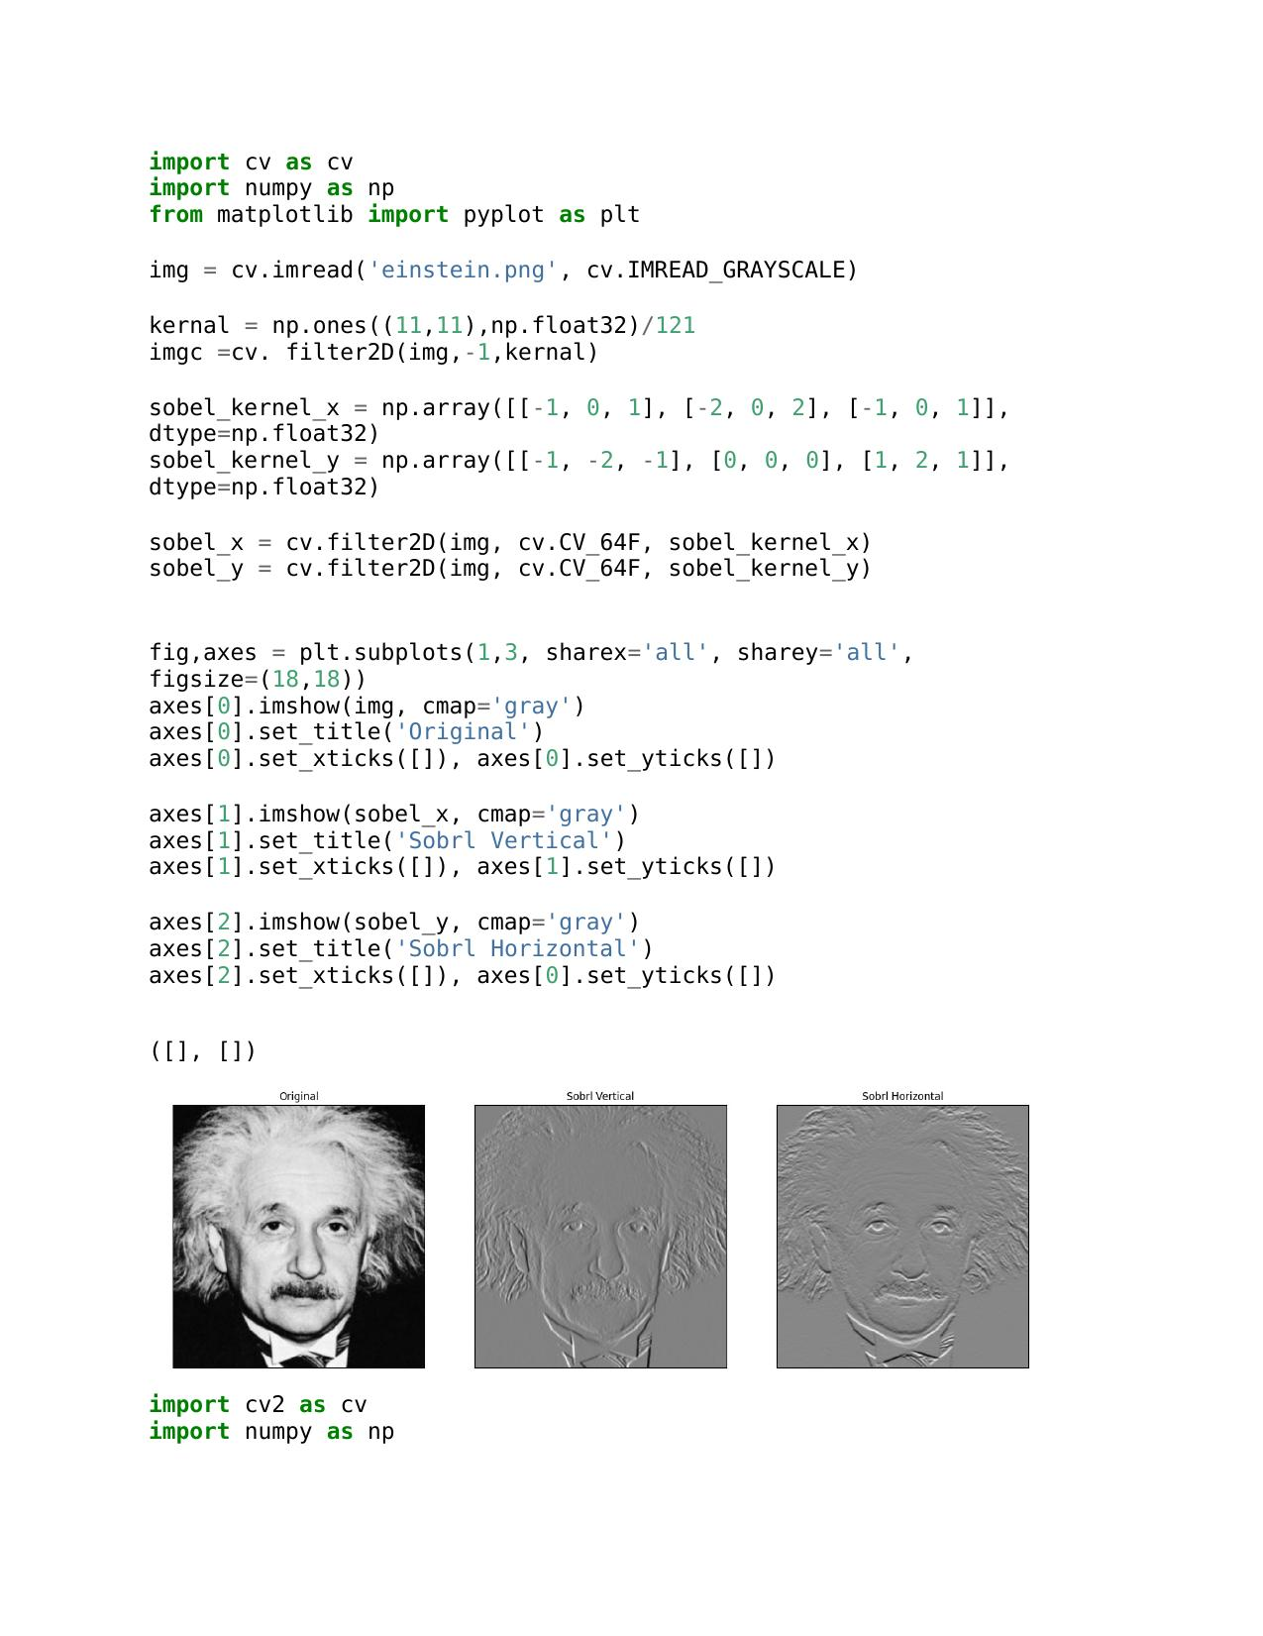

b..

a.

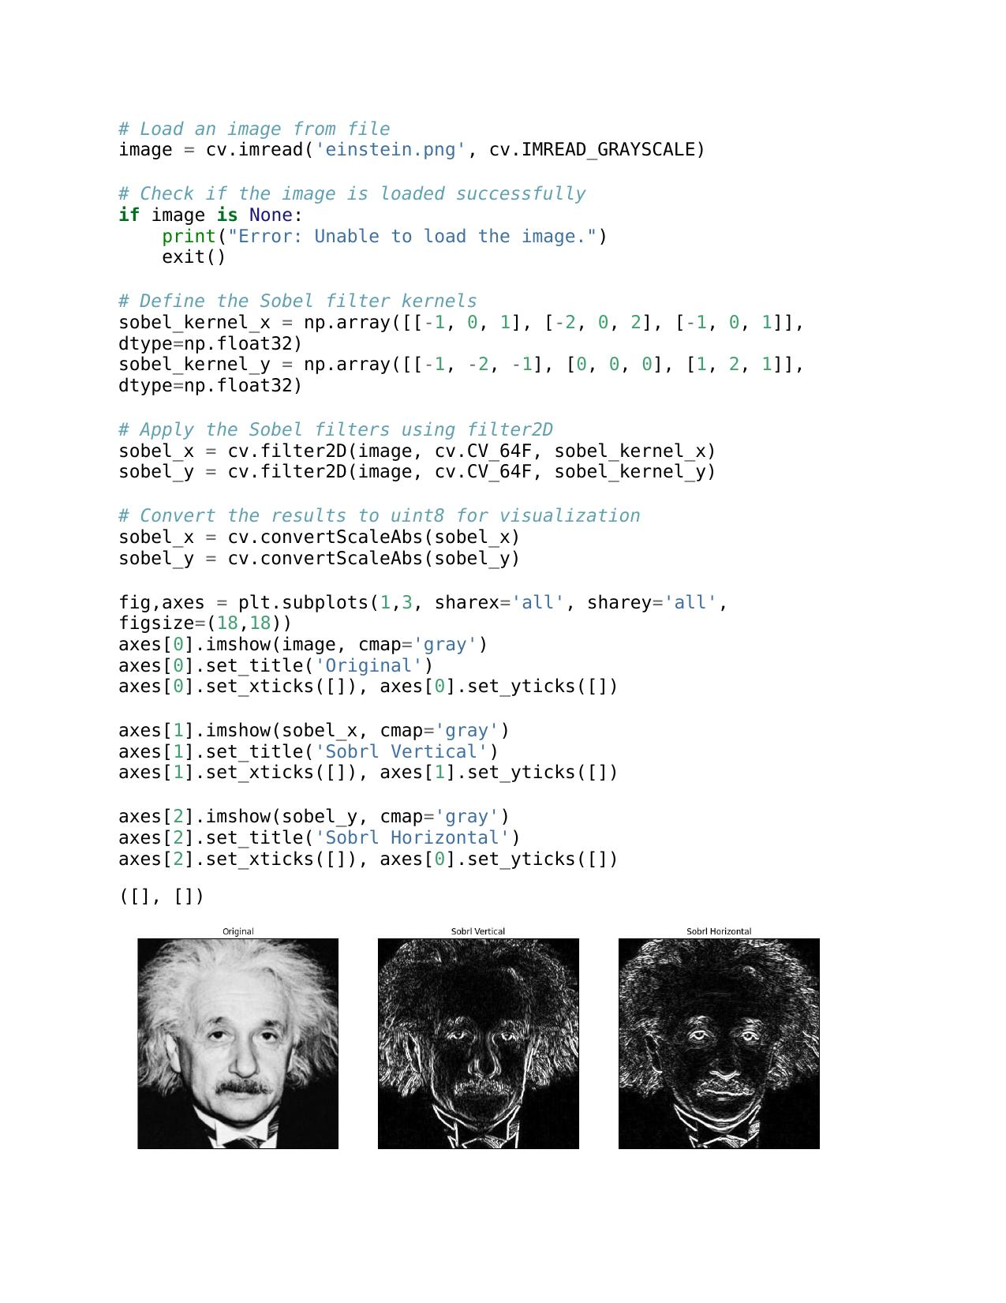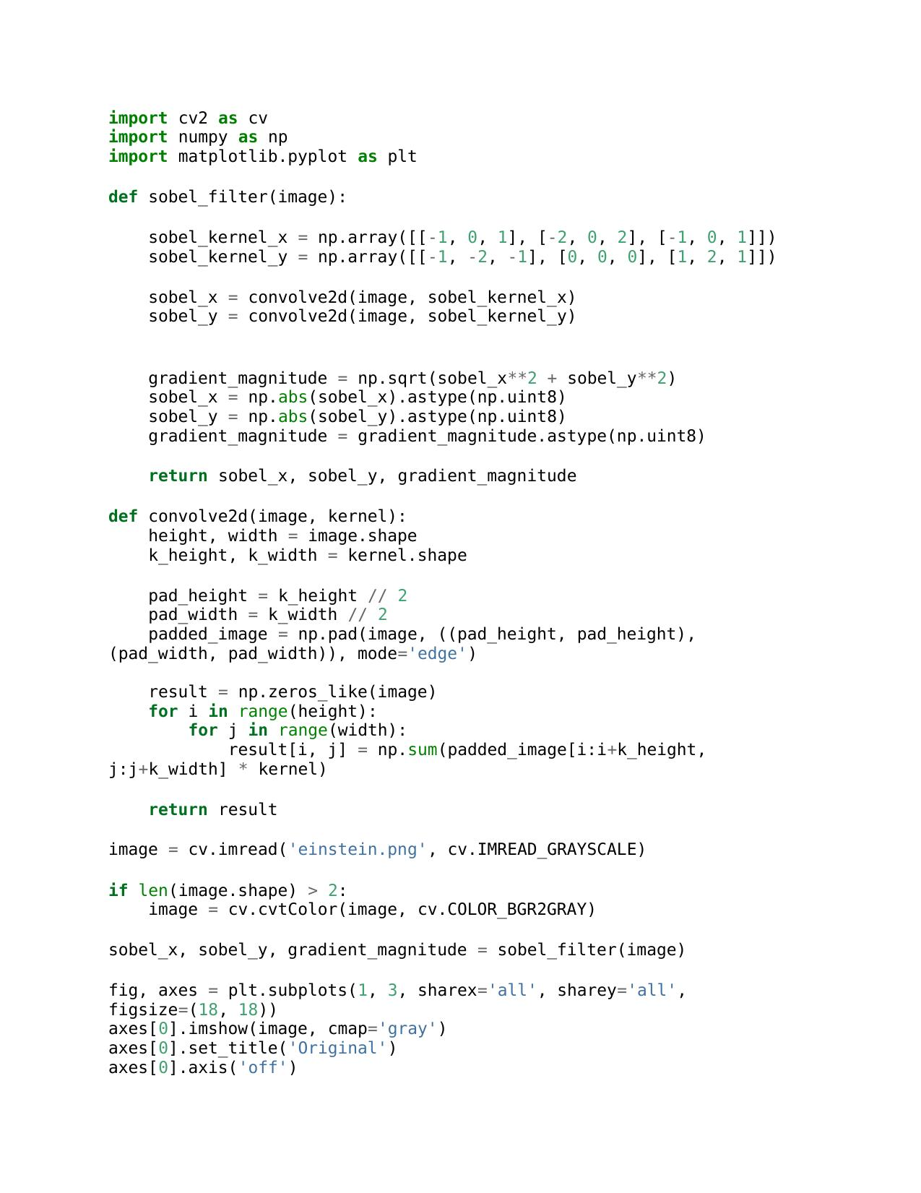

c.

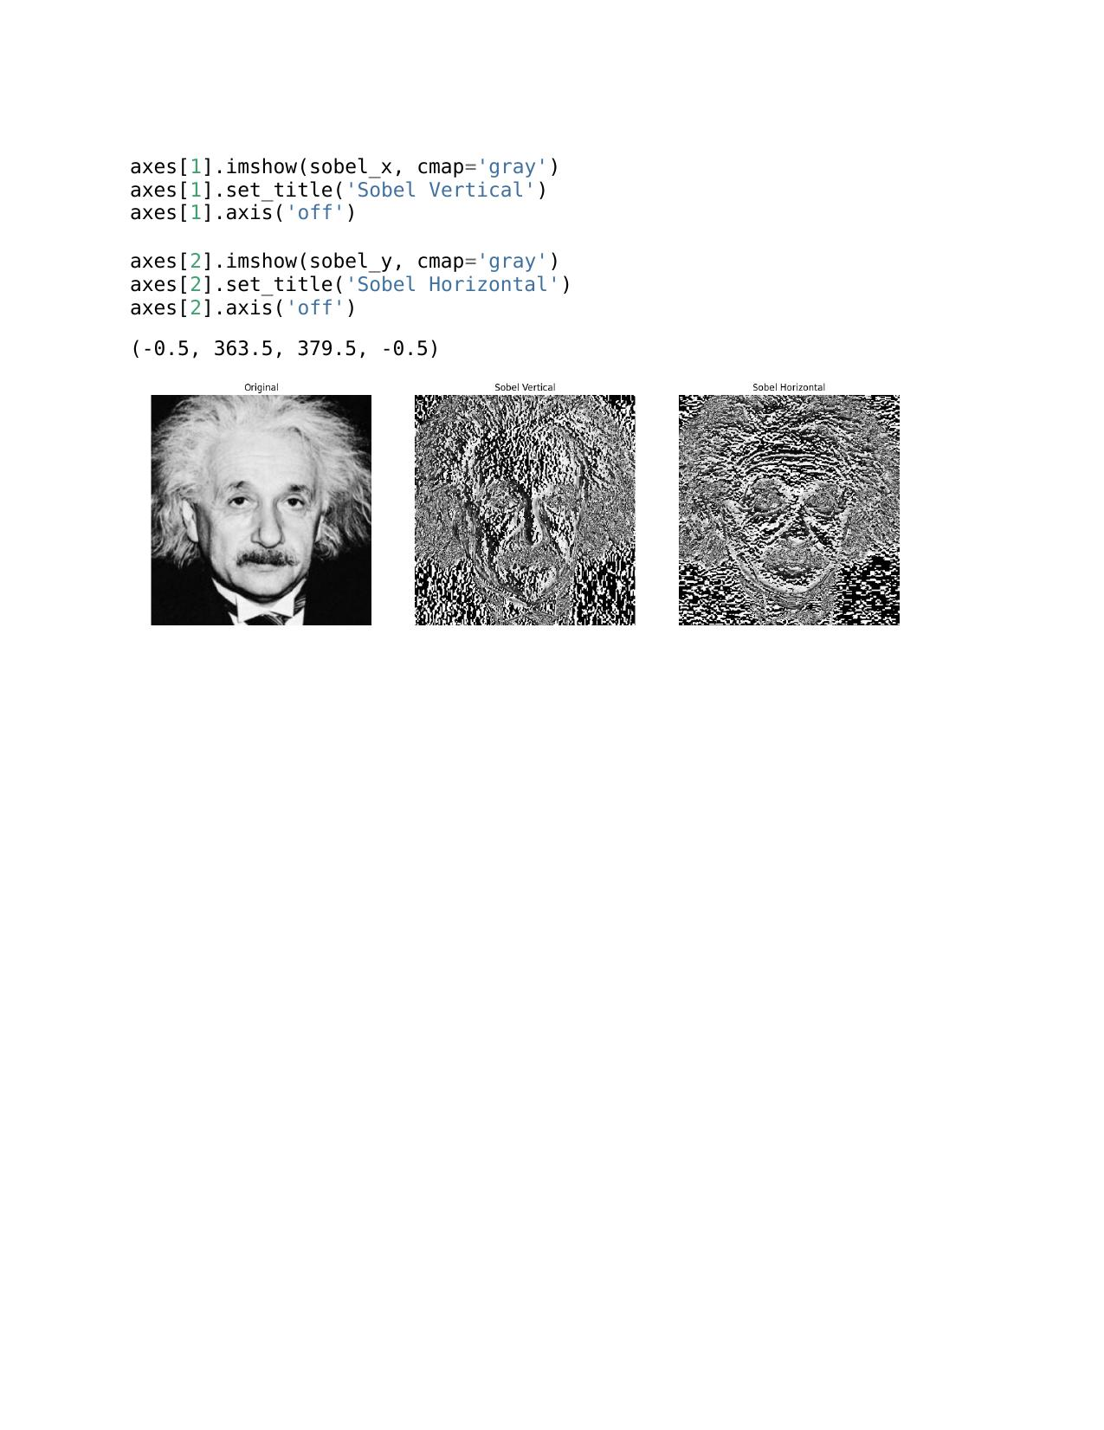

**Discussion**

l filtering is a crucial technique in image processing that emphasizes intensity changes for edge detection. In the context of Figure 6, three approaches are employed. First, with the existing filter2D function, Sobel filtering may be completed efficiently and rapidly. Second, a custom Sobel filter implementation offers an interactive understanding of the underlying computations.

**Question 07**

a.

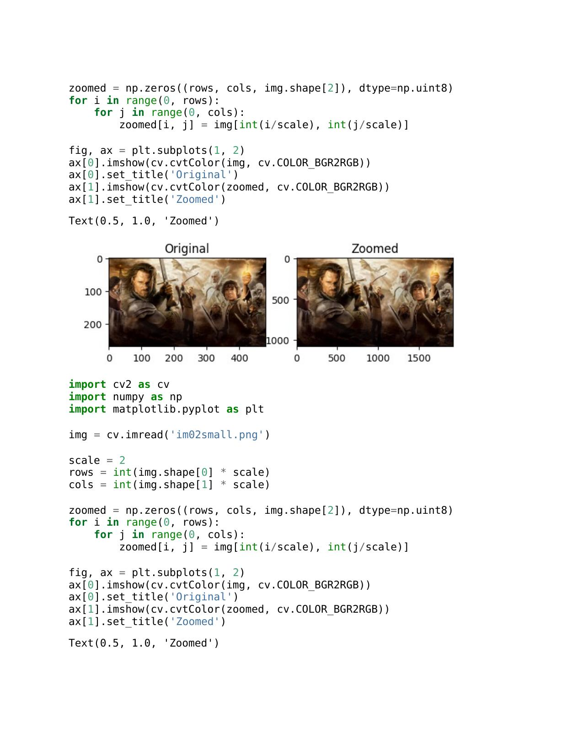

b.

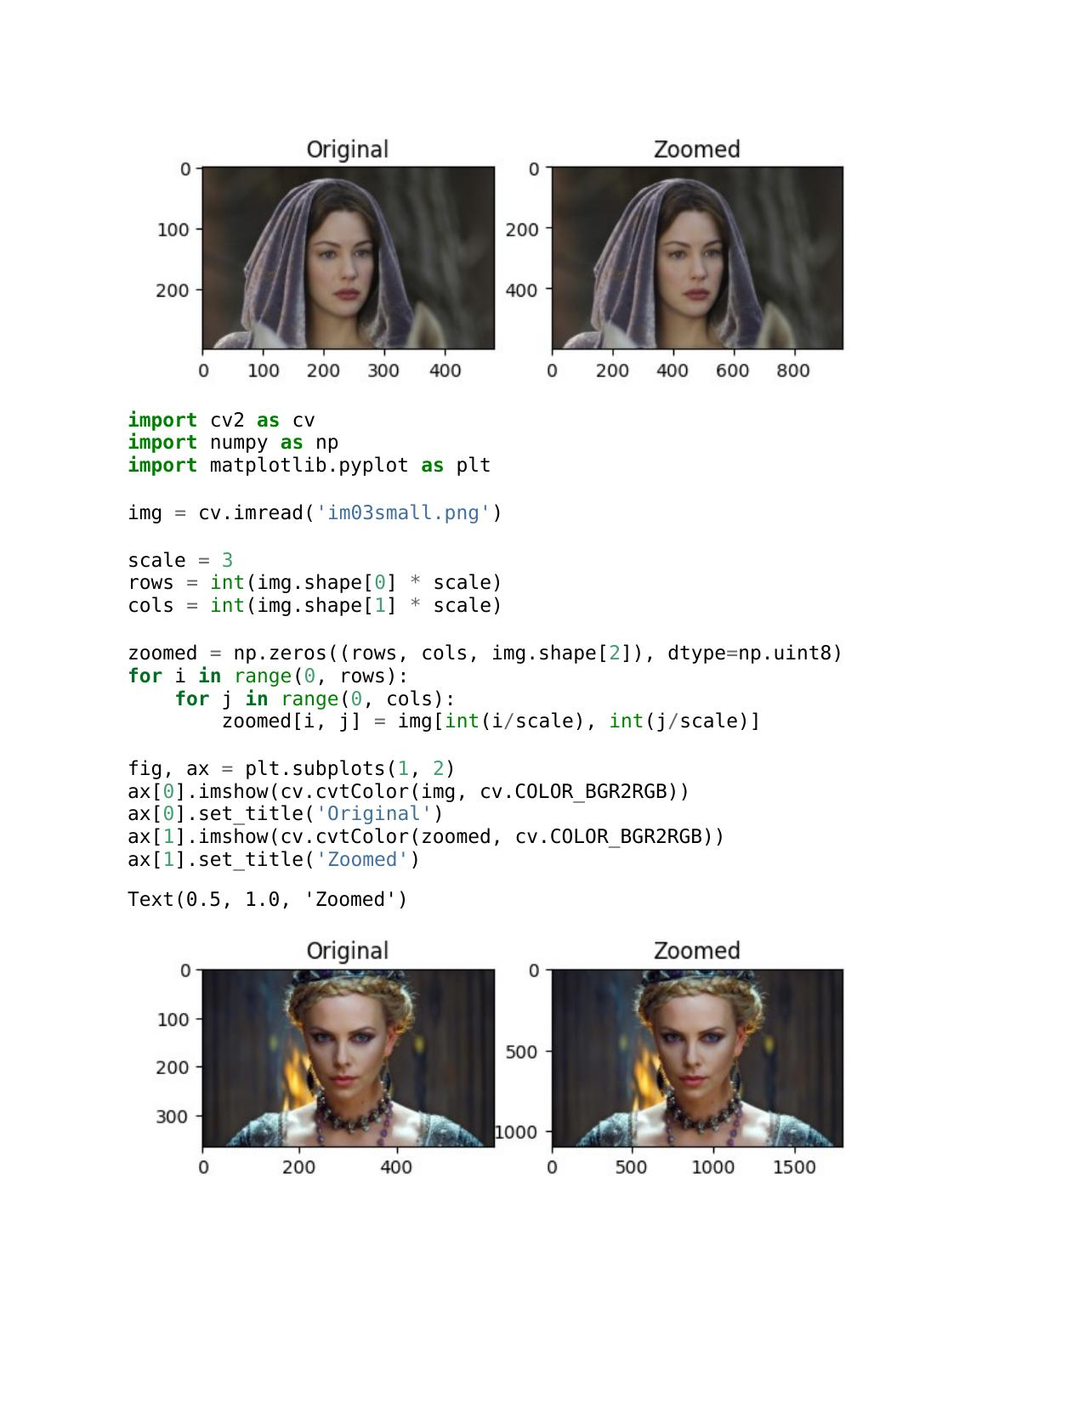

**Question 08**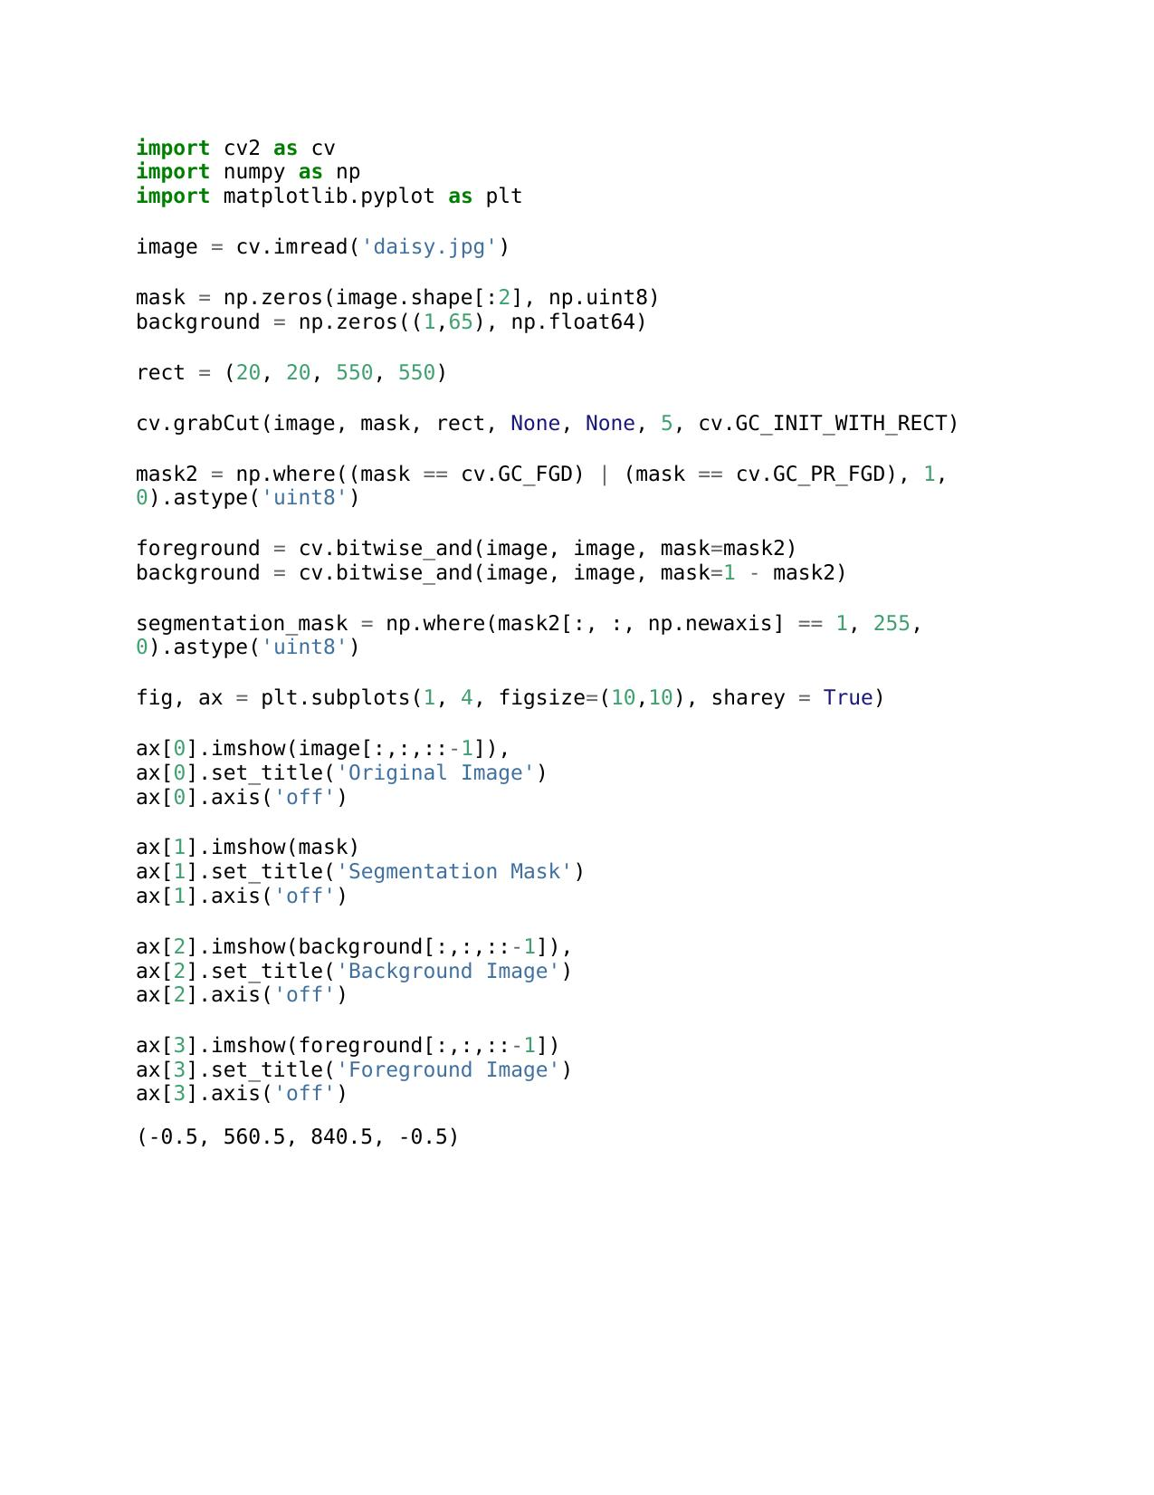

a.

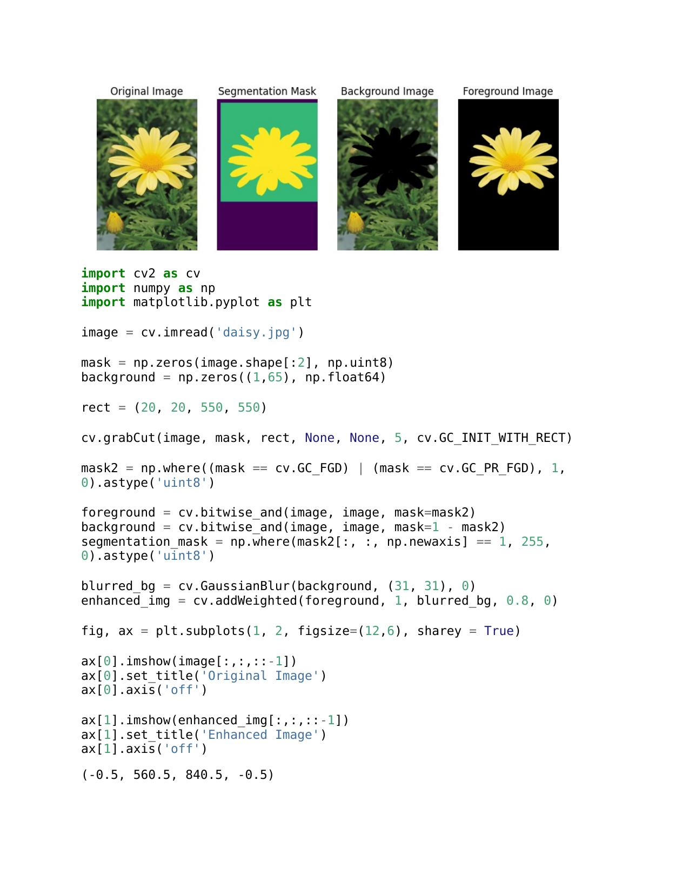

b.

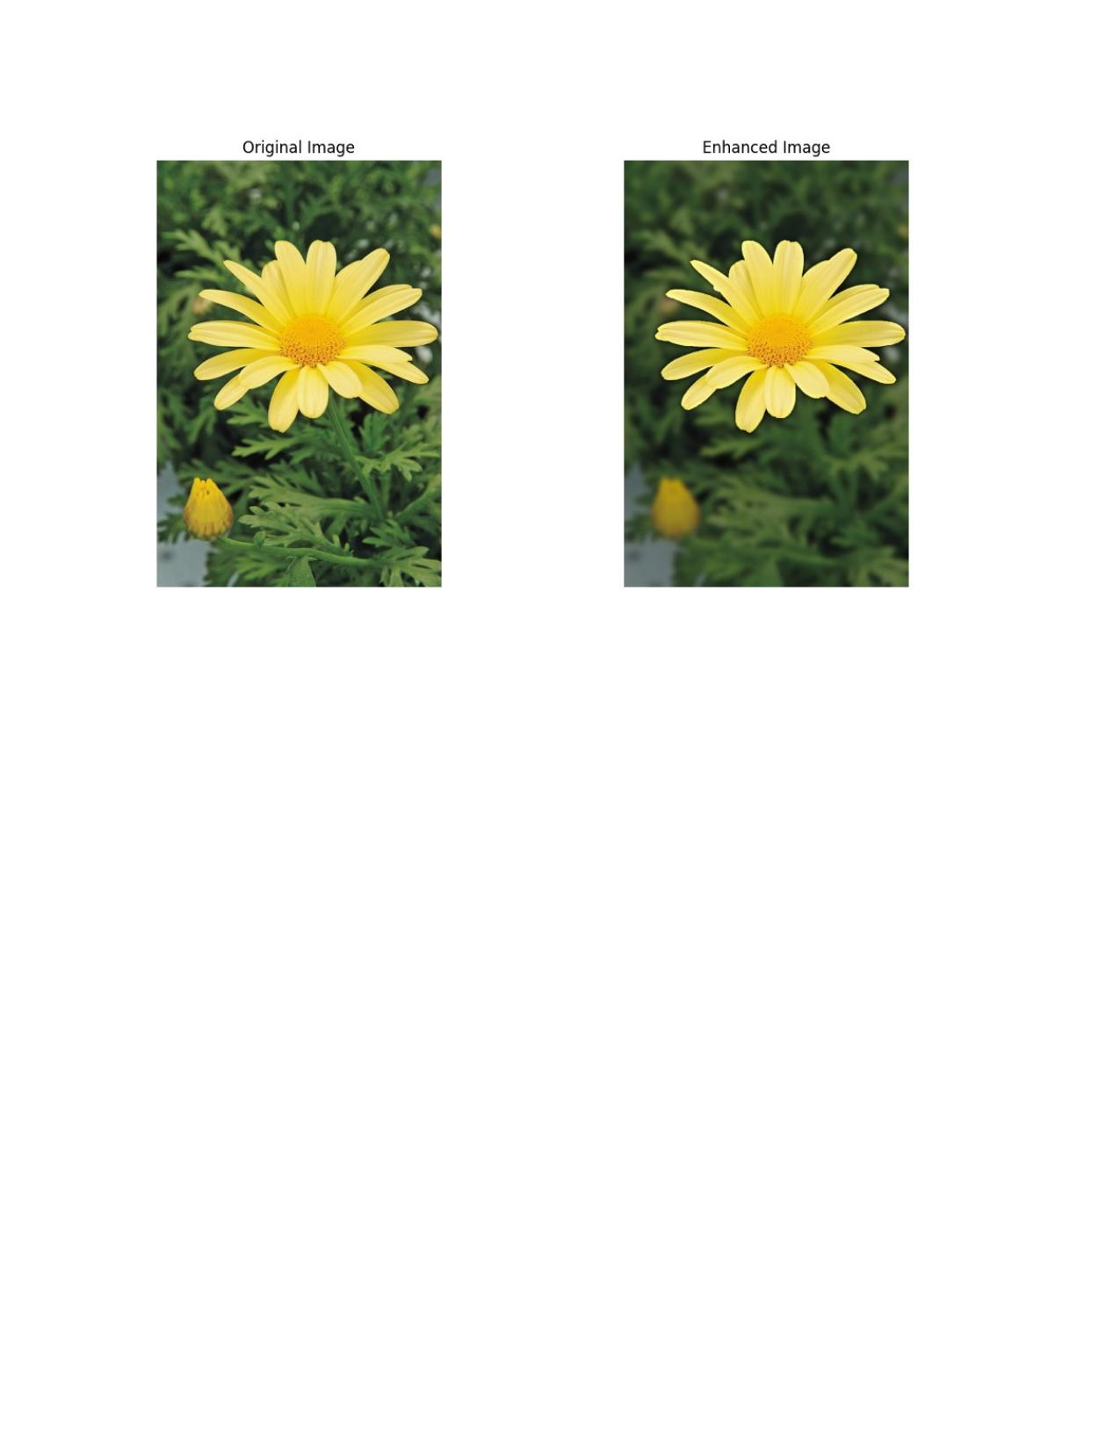

**c.** The improved image's darker backdrop, which extends over the margin of the flower, is mostly the outcome of a Gaussian blur applied to the background. The image is first divided into foreground (flower) and background using Grab Cut. The background is then smoothed using a Gaussian blur with a (15, 15) kernel. The backdrop appears darker because of this smoothing effect, which averages pixel values. The final improved image is produced by combining the sharp foreground with the blurred backdrop. The degree of blurring and the ensuing darkness in the backdrop can be altered by varying certain parameters, such as the kernel size.

**GitHub Link**

<https://github.com/Sandeepa0/Image-Processing.git>